The Goodwins Race

Sunday 17TH July 2022

Ramsgate Week Regatta 2022
IRC Handicap Classes
& Committee Boat Line
Monday 18TH - Friday 22ND July

SAILING INSTRUCTIONS
Version 1.0c

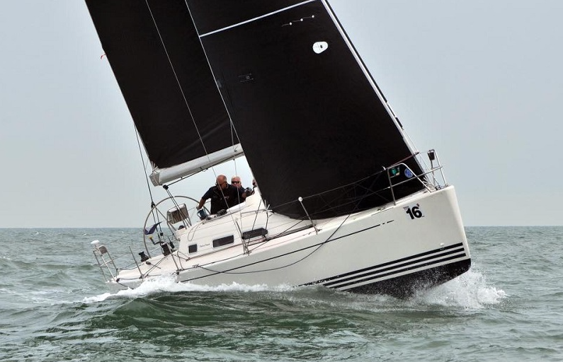

1. RULES
1.1 The regatta will be governed by the rules as defined in The Racing Rules of Sailing and the Port of Ramsgate By-laws.
1.2 SHIPPING AND PORT REGULATIONS
1.2.1 Any boat infringing the International Regulations for Preventing Collisions at Sea or by-laws in respect of commercial shipping may be protested by the Race Committee for infringement of this requirement.
1.2.2 An engine shall be used when appropriate to avoid risk of collision with another vessel that is under way but not racing, or in grave emergency. The facts shall be reported to the RC at the finish, with written details to the race office before the protest time limit.
1.2.3 Ramsgate By-laws copy at www.ramsgateweek.com or direct link http://www.portoframsgate.co.uk/royal-harbour-marina/marina-services/

- NOTICES TO COMPETITORS
  - Notices to competitors will be posted on the official notice board located on the ground floor of the Royal Temple Yacht Club. All notices will also be communicated via the competitors ‘What’s App’ group. Notices relating to the re-scheduling of races will also be posted on the notice board near to the entrance to the Western Marina. The results office is located at Royal Temple Yacht Club’s clubhouse.
Results will be available via https://www.halsail.com/Result/Club/1994
and when possible, displayed on the bar screens
3. CHANGES TO SAILING INSTRUCTIONS
3.1 Any change to the Sailing Instructions will be posted before 0830 on the day it will take effect, except that any change to the schedule of races will be posted by 2000h the day before it will take effect.
3.2 Verbal amendments to the Sailing Instructions may be advised by the Race Committee on VHF Channel 77 and flag L over H will be displayed on the committee boat. Flag L over H means “there is a change to the Sailing Instructions, come within hail or make radio contact if not understood”. This is in addition to the meaning of flag L in Race Signals.
4. SIGNALS MADE ASHORE
4.1 Signals made ashore will be displayed on the flagpole near the entrance to the Western Marina.
4.2 When flag AP is displayed ashore, “1 minute” is replaced with “not less than 60 minutes” in the race signal AP. This is additional to the meaning of flag AP in the Race Signals.
4.3 When flag Y is displayed ashore Rule 40 always applies while afloat. This changes the Part 4 preamble.

5. BRIEFING AND SCHEDULE OF RACES
5.1 There will be a briefing by Radio (VHF Channel 77) before the first race each day. This briefing will be broadcast approximately 30 minutes before the first warning signal is displayed. It is important that all competitors listen to information provided. Failure to receive this broadcast will not be grounds for redress. This changes rule 62.1(a).
5.2 Races are scheduled as follows: -
Date |  | Class | Warning Signal | Races
Sunday  17TH July |  | 5 & 6  2  1 | 0945  0955  1000 | Round the Goodwins
Monday  18TH July |  | 2  1 | 1055  1100 | Regatta Series  Race 1
Tuesday  19TH July |  | 2  1 | 1055  1100 | Regatta Series  Race 2
Wednesday  20th July |  | 2  1 | 1055  1100 | Regatta Series  Race 3  IRC Championship Regatta Series  Race 1
Thursday  21ST July |  | 2  1 | 1055  1100 | Regatta Series  Races 4 and 5  IRC Championship Regatta Series  Races 2 and 3 & QE11 Cup
Friday  22ND July |  | 5 &6  2  1 | 0945  0955  1000 | Regatta Series Race 5  Regatta Series Race 6  IRC Championship Regatta Series Race 4  Ramsgate Gold Cup

5.3 There will be Three IRC classes and the ‘’Rating Bands’’ will confirmed posted by 1800 on Saturday 16th July.
Class 1 TCC 1.000 and above
Class 2 TCC 0.999 and below
Two Handed IRC Class will race as scheduled for Round the Goodwins within the appropriate IRC Class and have their results extracted.

5.4 One design and ORC Classes with three or more entries will have results extracted from their relevant IRC class to form a class.
5.5 Boats are required to display their Class Flag (with a hoist of not less than 9 inches) on their backstay.
5.6 When more than one race will be held on the same day the warning signal for the first class to start the succeeding race will be made as soon as practicable. To alert boats that another race will be held soon the race committee boat will display an Orange flag with a long sound signal not less than 4 minutes before a warning signal is displayed for the first class to start.
5.7 The race committee may amalgamate classes or vary the order of starting for subsequent races depending on when classes complete their previous race. Full details of any changes will be provided on VHF Channel 77.
6. RACING AREAS
The racing areas will between East Margate and South Foreland.
7. THE COURSES
7.1 The marks to be rounded and the sequence of rounding will be displayed on a board on the committee boat before the warning signal for each class. The rhumb line between marks may not be navigable.
It is also the intention to broadcast the courses by ‘What’s App’, one for IRC Classes and one for Cruiser Classes 5,6&7.
At Registration Competitors must check Sail and ‘What’s App’ numbers are correct.
7.2 No later than the first warning signal the Committee Boat will display the approximate bearing to the first mark of the course.
7.3 The course configuration and identifying of marks will be broadcast on VHF Channel 77 approximately 10 minutes before the first warning signal is displayed.

7.4 The provisional course for The Goodwins race on Sunday 17TH July will be as follows:
Start in vicinity of RTYC 1 Ex Northrop Sails (34) & Ivor Thomas Amusements (8)
Drop mark X approximately 1 mile to windward (rounding subject to wind direction).
Goodwin Knoll (22) S
E Goodwin Buoy (17) S
E Goodwin Light Vessel (18) S
S Goodwin Buoy (38) S
SW Goodwin Buoy (43) S
S Brake Buoy (37) P
Finish at Euromarine Buoy (47) S
Course will be confirmed on the day via VHF Channel 77 before the Start.

8. MARKS
8.1 Marks are buoys in the Ramsgate Week list of marks the number and approximate position are available at Waypoints2022.pdf (ramsgateweek.com)
8.2 Additional marks may be laid and designated ‘X’, ‘Y’ or ‘Z’. These will be orange inflatable pillar marks and approximate position will be broadcast on VHF Channel 77.
8.3 Boats fouling a mark anchor line will not have grounds for redress. This changes rule 62.1 (a).

9. THE START
9.1 The starting line will be between the mast on the Committee Boat displaying an orange flag and an outer distance mark which will be an orange inflatable buoy or a course mark. The committee boat may be positioned at the Starboard or Port end of the line.
9.2 A boat starting later than 4 minutes after her starting signal will be scored “Did not start”. This changes Rule A4 and A5. This does not apply to Classes 5 & 6 for Round the Goodwins and Ramsgate Gold Cup when 9 minutes will apply.
9.3 Sail numbers of boats OCS or infringing other starting rules may be given on VHF Channel 77.
9.4 Classes whose warning signal has not been displayed must keep clear of the starting area and all boats whose warning signal has been made. Boats infringing this instruction may be protested by the race committee and the penalty may be DSQ.
9.5 A boat may use her engine or be towed to get to the starting area, after her preparatory signal provided that, before she starts, she stops using her engine for propulsion, or drops her tow and then takes a one turn penalty including one tack and one gybe.

10. CHANGE OF THE NEXT LEG OF THE COURSE
10.1 A change of course after the start will be signalled before the leading boat has begun the first leg affected. The new course to be sailed will be displayed on a boat stationed at a mark following which rounding the new course is to apply. The mark numbers and sequence will be displayed as designated in SI 7.1 and a horn will be sounded. This changes Rule 33.

11. THE FINISH
11.1 The finishing line will be between the mast on the Committee Boat displaying an orange flag and the designated mark of the course.
For the Round the Goodwins Race, Boats are asked to radio the ‘’Offshore 1’’ when approaching the finish line on VHF 77.

12. TIME LIMITS
12.1 There are no time limits, and the Race Committee may shorten the course at any time and for any reason. This changes Rule 32.
13. PROTESTS AND REQUESTS FOR REDRESS
13.1 Protest forms are available in your race pack. Protests and requests for redress or re-opening shall be delivered to the Race Results Office within the appropriate time limit.
13.2 The protest time limit is 90 minutes after the last boat has finished the last race of the day.
13.3 A mediation system is available for protests of rules in RRS Part 2. Provided all parties to the protest agree to mediation, the procedure to be adopted is to be found in the Appendix to these sailing instructions.
13.4 Notices will be posted no later than 30 minutes after the protest time limit to inform competitors of hearings in which they are parties or named as witnesses. Hearings will be held in the protest room at Royal Temple Yacht Club’s clubhouse.

13.5 Rule 61.1(b) is amended so that the listing of a boat on the Protest Schedule shall constitute informing the boat and the time limit is altered accordingly. It shall be the sole responsibility of the competitors to check the official notice board and to attend any protest hearing together with witnesses.
13.6 On the last scheduled day of racing a request for re-opening a hearing shall be delivered
- within the protest time limit if the requesting party was informed of the decision on the previous day.
- no later than 30 minutes after the requesting party was informed of the decision on that day. This changes Rule 66.
13.7 Breaches of instructions 5.5 and 15 will not be grounds for a protest by a boat. This changes Rule 60.1(a). Penalties for these breaches may be less than disqualification if the protest committee so decides. The scoring abbreviation for a discretionary penalty imposed under this instruction will be DPI.
13.8 On the last scheduled day of racing a request for redress based on a protest committee decision shall be delivered no later than 30 minutes after the decision was posted. This changes Rule 62.2.

14. SCORING
14.1 The regatta will be scored using the Low Points system of RRS Appendix A.
14.2 Two races are required to be completed to constitute a series.
14.3 When fewer than four races have been completed, a boat’s series score will be the total of her race scores.
14.4 When four races have been completed a boat’s series score will be the total of her race scores with her worst score discarded.
14.5 All times will be corrected to the nearest second to determine finishing place and with ·5 seconds round up,
14.6 The Noot Cup for Round the Goodwins on Sunday 17th July and the Ramsgate Gold Cup Friday 22ND July will be awarded to the IRC boat with the lowest corrected time. IRC Classes and Cruiser Classes 5 and 6 may sail the same course for these races. Separate trophies will be awarded for Classes 5 and 6.

15. SAFETY
15.1 A boat that retires from a race shall notify the race committee on VHF Marine Channel 77 or by telephone 07933 783263 as soon as possible after retirement.
15.2 Boats equipped with AIS transmitters are requested to transmit during the Round the Goodwins race in order that the race committee can monitor progress.
15.3 The race committee may issue GPS plotting devices to competitors. Full details will be provided at registration if this is to apply.

16. MEASUREMENT CHECKS
A boat or equipment may be inspected at any time for compliance with the class rules and sailing instructions.

17 RADIO COMMUNICATION
17.1 Except in an emergency, a boat shall neither make radio transmissions while racing nor receive radio communications not available to all boats. This restriction also applies to mobile telephones and other digital communication devices.
17.2 The race committee will use VHF Marine Channel 77 to communicate with competitors. Such communications may include sail numbers of boats recalled OCS, course changes and safety matters. Boats called by the race committee by name or sail number may respond and under such circumstances will not be in breach of instruction 17.1. Failure to broadcast by the race committee or to time it accurately or failure to receive a broadcast by the race committee will not be grounds for redress. This changes Rule 62.1(a)
18. PRIZES
Prizes will be awarded as listed in the Notice of Race.
19. RISK AND RESPONSIBILITY STATEMENT

19.1 Rule 4 of the Racing Rules of Sailing states “The responsibility for a boat’s decision to participate in a race or to continue racing is hers alone.”
19.2 Royal Temple Yacht Club accept no responsibility or liability for loss of life or injury to skipper or crew or others, or for the loss of, or damage to, any vessel or property.
19.3 The skipper and crew shall be held jointly responsible for the conduct of the boat’s crew before, during and after a race. Misconduct may result in both the person in charge and crew being excluded from future races and renders a boat liable to disqualification.
19.4 The race committee shall make starting signals unless in their opinion it is manifestly unsafe for any of the boats entered to remain in the vicinity of the starting line. Each boat shall exercise her responsibility under Fundamental Rule 4 Decision to Race and decide whether to start or to continue to race.
19.5 No boat shall be accepted as an entry unless the skipper of the boat has, before the start of the race, signed a declaration in the terms set out in the entry form.
19.6 Sailing is by its nature an unpredictable sport and therefore inherently involves an element of risk. By taking part in the event, each competitor agrees and acknowledges that:
19.6.1 They are aware of the inherent element of risk involved in the sport and accept responsibility for the exposure of themselves, their crew and their boat to such inherent risk whilst taking part in the event.
19.6.2 They are responsible for the safety of themselves, their crew, their boat and their property whether afloat or ashore.
19.6.3 They accept responsibility for any injury, damage or loss to the extent caused by their own actions or omissions.
19.6.4 Their boat is in good order, equipped to sail in the event and they are fit to participate
19.6.5 The provision of a race management team, patrol boats and other officials and volunteers by the event organiser does not relieve them of their own responsibilities.
19.6.6 The provision of patrol boat cover is limited to such assistance, particularly in extreme weather, as can be practically provided in the circumstances.

19.6.7 Vessels setting to sea for offshore and coastal races are responsible for ensuring that their boat is equipped and seaworthy to be able to face extremes of weather; that there is a crew sufficient in number, experience, and fitness to withstand such weather; and that safety equipment is properly maintained, stowed and in date and is familiar to the crew.
19.7 The fact that the race committee conducts inspections of a boat does not reduce the responsibilities of each competitor set out in this Notice of Race.

20. INSURANCE Each participating boat shall be insured with sufficient insurance cover to meet all or any claims and with a minimum cover of £3,000,000 (GBP) in respect of third-party claims.
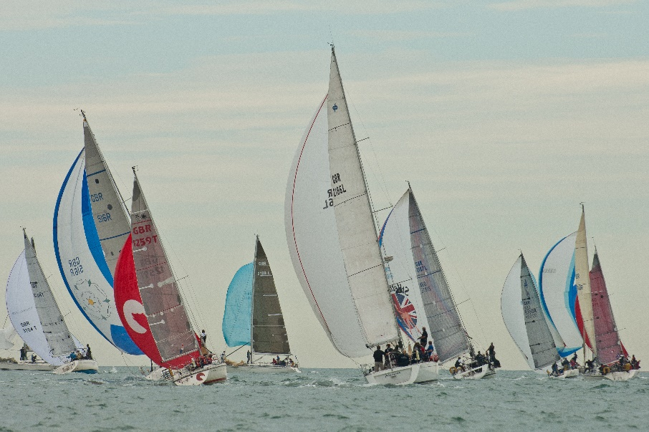

APPENDIX
MEDIATION
- After a protest has been lodged in accordance with the Sailing Instructions, all parties involved in protests alleging infringements of a rule of Part 2 shall be heard by a Mediator appointed by the Race Committee.
In exception to the above, incidents where damage or injury is involved shall not be subject to mediation, but shall be referred directly to the Protest Committee for a hearing.
- Only one party to the protest from each boat involved, who shall have been on the boat at the time the incident occurred, shall attend the mediation hearing. No witnesses shall be allowed.
- The mediator will have each party describe the incident, limiting each party to approximately 3 minutes. After hearing these descriptions, the mediator will offer one of the following opinions:
- No rule was broken.
If the protesting boat accepts this opinion, she can agree to withdraw the protest and the protest is then settled.
- A rule was broken by one of the boats involved.
If that boat accepts this opinion, she may accept a 40% penalty and the protest is then settled.
- Both boats broke a rule.
If both boats accept this opinion and each agrees to accept a 40% penalty then the protest is then settled.
- The mediator is unable to offer an opinion based on the brief description given by the parties.
- Once the protest has been settled under 3 a), b) or c) above, the mediator shall record this on the protest form and the matter shall not thereafter be referred to the protest committee and is not subject to requests for redress, reopening or appeal by any party.
If however:
- The protestor does not withdraw the protest under 3 a) above; or
- If a boat does not accept the mediator’s opinion that she broke a rule under b) or c); or
- If the mediator is unable to offer an opinion under d), the protest shall be submitted to the protest committee for a hearing.
- If the mediator’s opinion is not accepted, there shall be no further discussion of the incident with the parties and the testimony given at the mediation hearing shall remain confidential and shall not be discussed with any person prior to the protest hearing.
- If one party fails to attend, the mediation may still be heard in line with RRS 63.3 (b).
- Application of the 40% penalty shall be calculated in accordance with Rule 44.3, except that the penalty is modified to read 40%.

